# CHAPTER 1: DESIGN OF KITCHEN HOOD SYSTEM

A general kitchen hood is not just a steel box. Every commercial kitchen requires ventilation, and in the past, the significance of a proper ventilating system has been overlooked by the technical personnel. Today, designers, installers, and operators are recognizing the value in well-designed commercial kitchen ventilation (CKV) systems. Emphasizing “system” because it is not just a box, it is an engineered system of exhaust hoods, ventilators, make-up air ventilators, grease removal apparatuses and more. Taking time to properly design a CKV system will increase the health and safety of the kitchen operators and increase the efficiency and energy savings for the owner.

The design of the commercial kitchen hood depends on various factors like the area of application, types of appliances used and the air flow requirements as per the building and indoor conditions. The airflow includes both the exhaust air and the make-up air for the kitchen systems to maintain the indoor air quality and the pressure inside the building. Successfully applying the fundamentals of commercial kitchen ventilation (CKV) during the design process requires a good understanding of the local building code requirements, the menu and appliance preferences, and the project’s budget.

## 1.1 DESIGN PHILOSOPHY

Information about the kitchen equipment and ventilation requirements may evolve over the course of the design phase. Data needed by other members of the design team may require early estimates of certain parameters (e.g., the amount of exhaust and makeup air, motor horsepower, water supply and wastewater flow rates). As more decisions are made, new information may allow (or require) refinements to the design that affect exhaust and makeup air requirements.

The fundamental steps in the design of a CKV system are:

1. Establish location and “duty” classifications of appliances including menu effects. Determine (or coordinate with foodservice consultant) preferred appliance layout for optimum exhaust ventilation.
2. Select hood type, style, and features.
3. Size exhaust airflow rate.
4. Select makeup air strategy; size airflow and layout diffusers.

During development of ASHRAE Standard 154, Ventilation for Commercial Cooking Appliances, it was recognized that plume strength, which takes into account plume volume and surge characteristics, as well as plume temperature, would be a better measure for rating appliances for application in building codes. “Duty” ratings were created for the majority of commercial cooking appliances under Standard 154, and these were recently adopted by the International Mechanical Code (IMC). The Kitchen Ventilation chapter of the ASHRAE Applications Handbook (2003 edition) applied the same concept to establish ranges of exhaust rates for listed hoods. The duty classifications listed below are from ASHRAE Standard 154-2003, Ventilation for Commercial Cooking Operations.

The project deals with a commercial kitchen exhaust system for a restaurant for the multi-cuisine category having multiple options and locations of cooking for the foody needs. The cooking appliances are mostly parallel and near the wall location. As such the project further designs on wall type canopy for the cooking ranges and performs the design requirements and details. The below table provides the duty classification and also the air flow requirements for the wall type canopy kitchen hood.

|  |  |  |
| --- | --- | --- |
| **DUTY CLASSIFICATION** | **APPLIANCES** | **DESIGN CFM/Ft.** |
| **LIGHT** | * Gas and electric ovens * Electric and gas steam-jacketed kettles * Electric and gas compartment steamers (both pressure and atmospheric) * Electric and gas cheese-melters * Electric and gas re-thermalizers | 200 |
| **MEDIUM** | * Electric discrete element ranges (with or without oven) * Electric and gas hot-top ranges * Electric and gas griddles * Electric and gas double-sided griddles * Electric and gas fryers (including open deep-fat fryers, donut fryers, kettle fryers, and pressure fryers) * Electric and gas pasta cookers * Electric and gas conveyor (pizza) ovens * Electric and gas tilting skillets /braising pans * Electric and gas rotisseries | 300 |
| **HEAVY** | * Electric and gas underfired broilers * Electric and gas chain (conveyor) broilers * Gas open-burner ranges (with or without oven) * Electric and gas wok ranges * Electric and gas overfired (upright) broilers * Salamanders | 400 |
| **EXTRA-HEAVY** | * Appliances using solid fuel such as wood, charcoal, briquettes, and mesquite to provide all or part of the heat source for cooking | 550 |

*Table 1.1: Duty classification and Airflow design for wall canopy hoods*

## 1.2 EXHAUST AIR FLOW RATE

The calculation of proper exhaust rate is one of the most crucial calculations in a kitchen ventilation system. Not only will it allow the system to capture as it is designed, but can save money each year through energy savings as well as initial start-up costs. It is important to establish how contaminated air is generated and how it behaves.

The principle purpose of the kitchen hood system is to capture and contain the rising thermal/effluent plume coming off the cooking equipment. The circumstances that cause containment problems are air disturbance of the rising plume and lack of overhang to capture the heat or effluent. The first step in any hood with capture and containment problems is to observe airflow conditions. Introducing hot chemical smoke under the hood canopy helps to show air disturbance conditions or lack of removal by the exhaust flow. The hot smoke source is produced by placing a small can of sand into a boiling pan of water then lighting a smoke bomb in the sand inside the can. A smoke puffer also can be used to observe the airflow path of the cooling and replacement air systems to see which way the air is traveling toward the exhaust hood, the other exhaust systems, or the return air to the HVAC units.

Using any of the concepts, every piece of cooking equipment can be placed into a category which assigns a value to the actual updraft velocity or airflow volume per foot. These values can be used for CFM hood calculations. Recognize that the extra-heavy category contains nearly all solid fuel cooking appliances. Solid fuel is the most volatile and uncontrollable fuel source in a commercial cooking operation. There is no on/off switch like most appliances, but rather one can add fuel or let the fuel burn out. Thus, the load is extremely variable and may exceed projected exhaust requirements. In these situations, it is important to have additional airflow up front and size exhaust and supply fans so their airflow can be increased if needed. Lastly, look into standards and code requirements such as: Local Codes, State Codes, NFPA 96, IMC, or any other required agencies in the area to ensure proper installation.

## 1.3 DESIGN CALCULATIONS

The restaurant’s kitchen work for cooking is been split to 8 different locations, proposedly having to design 8 separate kitchen hoods as per the appliances used at that particular location. As per the location of appliances along-side of the wall, a wall type canopy is being selected and further designed as per the ASHRAE and Client requirements.

The design & selection can be done for the different systems and accessories for a commercial kitchen hood. The project hereon details on the exhaust and make up air requdirement with duct sizing for each to maintain the air flow system.

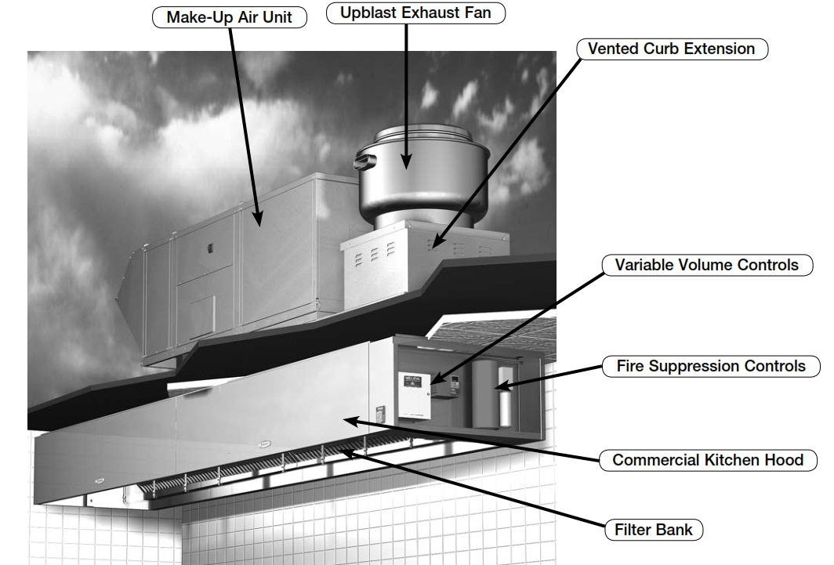

*Fig. 1.1: Wall Canopy – Commercial Kitchen Hood System*

**KITHCHEN HOOD -1:**

Appliances Used:

* + **Fryer (750x750mm) & Oven (900x900mm)**
  + Total length of the cooking appliances is 1650mm.
  + Type of Duty: Medium

Hood Design:

* + Hood covers the entire appliances and further overhang space on sides and front of 150mm (6”).
  + Total Hood length = Overhang + Total appliance length + Overhang

= 150 + 1650 + 150 = 1950mm. = 6.39 ft.

* + Exhaust flow rate = Hood Length x CFM per linear foot (Duty)

= 6.39 x 300 = 1918CFM = 1920 CFM.

* + Exhaust Duct Size as per commercial kitchen exhaust 1800fpm.

300mmx300mm.

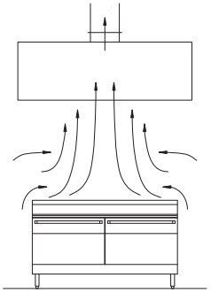

*Fig. 1.2: Exhaust air - Kitchen Hood*

Make-Up Air:

* + Fresh Air = 80% of Exhaust Air

= 1920 x 0.8 = 1536 CFM

* + Fresh Air Duct Size is 300x300mm
  + Grill selected for air flow at the hood (Compensating Hood).

**KITHCHEN HOOD -2:**

Appliances Used:

* + **Griddle (900x750mm) & Oven (900x900mm)**
  + Total length of the cooking appliances is 1800mm.
  + Type of Duty: Medium

Hood Design:

* + Hood covers the entire appliances and further overhang space on sides and front of 150mm (6”).
  + Total Hood length = Overhang + Total appliance length + Overhang

= 150 + 1800 + 150 = 2100mm. = 6.88 ft.

* + Exhaust flow rate = Hood Length x CFM per linear foot (Duty)

= 6.88 x 300 = 2065 CFM.

* + Exhaust Duct Size as per commercial kitchen exhaust 1800fpm.

350x350mm.

Make-Up Air:

* + Fresh Air = 80% of Exhaust Air

= 2065 x 0.8 = 1652 CFM

* + Fresh Air Duct Size is 300x300mm
  + Grill selected for air flow at the hood (Compensating Hood).

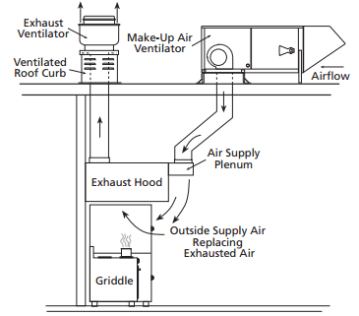

*Fig. 1.3: Make-up air - Kitchen Hood*

**KITHCHEN HOOD -3:**

Appliances Used:

* + **Fryer (750x750mm), Griddle (900x750mm) & Oven (900x900mm)**
  + Total length of the cooking appliances is 2550mm.
  + Type of Duty: Medium

Hood Design:

* + Hood covers the entire appliances and further overhang space on sides and front of 150mm (6”).
  + Total Hood length = Overhang + Total appliance length + Overhang

= 150 + 2550 + 150 = 2850mm. = 9.34 ft.

* + Exhaust flow rate = Hood Length x CFM per linear foot (Duty)

= 9.34 x 300 = 2800 CFM.

* + Exhaust Duct Size as per commercial kitchen exhaust 1800fpm.

400x400mm.

Make-Up Air:

* + Fresh Air = 80% of Exhaust Air

= 2800 x 0.8 = 2240 CFM

* + Fresh Air Duct Size is 350x350mm
  + Grill selected for air flow at the hood (Compensating Hood).

**KITHCHEN HOOD -4:**

Appliances Used:

* + **Fryer (750x750mm), Griddle (900x750mm), Char-Broiler (900x750mm) & Oven (900x900mm)**
  + Total length of the cooking appliances is 3450mm.
  + Type of Duty: Medium

Hood Design:

* + Hood covers the entire appliances and further overhang space on sides and front of 150mm (6”).
  + Total Hood length = Overhang + Total appliance length + Overhang

= 150 + 3450 + 150 = 3750mm. = 12.3 ft.

* + Exhaust flow rate = Hood Length x CFM per linear foot (Duty)

= 12.3 x 300 = 3690 CFM.

* + Exhaust Duct Size as per commercial kitchen exhaust 1800fpm.

450x450mm.

Make-Up Air:

* + Fresh Air = 80% of Exhaust Air

= 3690 x 0.8 = 2952 CFM

* + Fresh Air Duct Size is 350x350mm
  + Grill selected for air flow at the hood (Compensating Hood).

**KITHCHEN HOOD -5:**

Appliances Used:

* + **Fryer (750x750mm), Griddle (900x750mm), Char-Broiler (900x750mm) & Oven (900x900mm)**
  + Total length of the cooking appliances is 3450mm.
  + Type of Duty: Medium

Hood Design:

* + Hood covers the entire appliances and further overhang space on sides and front of 150mm (6”).
  + Total Hood length = Overhang + Total appliance length + Overhang

= 150 + 3450 + 150 = 3750mm. = 12.3 ft.

* + Exhaust flow rate = Hood Length x CFM per linear foot (Duty)

= 12.3 x 300 = 3690 CFM.

* + Exhaust Duct Size as per commercial kitchen exhaust 1800fpm.

450x450mm.

Make-Up Air:

* + Fresh Air = 80% of Exhaust Air

= 3690 x 0.8 = 2952 CFM

* + Fresh Air Duct Size is 350x350mm
  + Grill selected for air flow at the hood (Compensating Hood).

**KITHCHEN HOOD -6:**



Appliances Used:

* + **Fryer (750x750mm), Griddle (900x750mm), Char-Broiler (900x750mm) & Range (750x750mm)**
  + Total length of the cooking appliances is 3300mm.
  + Type of Duty: Medium

Hood Design:

* + Hood covers the entire appliances and further overhang space on sides and front of 150mm (6”).
  + Total Hood length = Overhang + Total appliance length + Overhang

= 150 + 3300 + 150 = 3600mm. = 11.8 ft.

* + Exhaust flow rate = Hood Length x CFM per linear foot (Duty)

= 11.8 x 300 = 3540 CFM.

* + Exhaust Duct Size as per commercial kitchen exhaust 1800fpm.

450x450mm.

Make-Up Air:

* + Fresh Air = 80% of Exhaust Air

= 3540 x 0.8 = 2832 CFM

* + Fresh Air Duct Size is 400x400mm
  + Grill selected for air flow at the hood (Compensating Hood).

**KITHCHEN HOOD -7:**

Appliances Used:

* + **Griddle (900x750mm) & Oven (900x900mm)**
  + Total length of the cooking appliances is 1800mm.
  + Type of Duty: Medium

Hood Design:

* + Hood covers the entire appliances and further overhang space on sides and front of 150mm (6”).
  + Total Hood length = Overhang + Total appliance length + Overhang

= 150 + 1800 + 150 = 2100mm. = 6.88 ft.

* + Exhaust flow rate = Hood Length x CFM per linear foot (Duty)

= 6.88 x 300 = 2065 CFM.

* + Exhaust Duct Size as per commercial kitchen exhaust 1800fpm.

350x350mm.

Make-Up Air:

* + Fresh Air = 80% of Exhaust Air

= 2065 x 0.8 = 1652 CFM

* + Fresh Air Duct Size is 300x300mm
  + Grill selected for air flow at the hood (Compensating Hood).

**KITHCHEN HOOD -8:**

Appliances Used:

* + **Bar Be Que (1700x300mm)**
  + Total length of the cooking appliances is 1700mm.
  + Type of Duty: Light

Hood Design:

* + Hood covers the entire appliances and further overhang space on sides and front of 150mm (6”).
  + Total Hood length = Overhang + Total appliance length + Overhang

= 150 + 1700 + 150 = 2000mm. = 6.55 ft.

* + Exhaust flow rate = Hood Length x CFM per linear foot (Duty)

= 6.55 x 200 = 1310 CFM.

* + Exhaust Duct Size as per commercial kitchen exhaust 1800fpm.

250x250mm.

Make-Up Air:

* + Fresh Air = 80% of Exhaust Air

= 1310 x 0.8 = 1048 CFM

* + Fresh Air Duct Size is 250x250mm
  + Grill selected for air flow at the hood (Compensating Hood).

# CHAPTER 2: DISCUSSION OF RESULTS

The project delivers detail design and information that will help achieve optimum performance and energy efficiency in commercial kitchen ventilation systems by properly selecting and sizing exhaust hoods. The information presented is applicable to new construction and, in many instances, retrofit construction. The beneficiaries of this information can be kitchen designers, mechanical engineers, code officials, food service operators, property managers, and maintenance people.

The kitchen hood selected for each of the appliance set location are as given below.

|  |  |  |  |  |
| --- | --- | --- | --- | --- |
| **S.No** | **Kitchen Hood No.** | **Size** | **Exhaust**  **CFM** | **Make-up Air**  **CFM** |
| 1 | Kitchen Hood - 1 | 1950x1050mm | 1920 | 1536 |
| 2 | Kitchen Hood – 2 | 2100x1050mm | 2065 | 1652 |
| 3 | Kitchen Hood – 3 | 2850x1050mm | 2800 | 2240 |
| 4 | Kitchen Hood – 4 | 3750x1050mm | 3690 | 2952 |
| 5 | Kitchen Hood – 5 | 3750x1050mm | 3690 | 2952 |
| 6 | Kitchen Hood – 6 | 3600x1050mm | 3540 | 2832 |
| 7 | Kitchen Hood - 7 | 2100x1050mm | 2065 | 1652 |
| 8 | Kitchen Hood - 8 | 2000x500mm | 1310 | 1048 |

*Table 2.1: Results of Kitchen Hood sizing and air flow rates*

The results of the project to design the commercial kitchen ventilation system clearly identify the inputs for improving the efficiency of the air flow in & out of the restaurant kitchens. The sizing of such hoods has been done to circulate the air without effecting the working performance of the kitchens. The sizing and performance mandates that the effluents and heat is not spilled into the kitchen arena but completely is been removed and replaced with fresh air.

The exhaust air is being removed from the kitchen by help of ducting system through exhaust fans selected as per the capacity required. Two exhaust fans are installed on the roof for the same as per below table.

|  |  |  |  |
| --- | --- | --- | --- |
| **S.No** | **Exhaust Air Fan No.** | **Exhaust From** | **Exhaust Air**  **CFM** |
| 1 | AC-EF-01 | Kitchen Hood – 1,2,3,4,5,8 | 15475 |
| 2 | AC-EF-02 | Kitchen Hood – 6,7 | 5605 |

*Table 2.2: Exhaust Air Fan Capacity*

The make-up air or fresh air is supplied through fans selected and supplied through ducts to each kitchen hood and released by grills in front of the kitchen hood. The fans thus selected are as below.

|  |  |  |  |
| --- | --- | --- | --- |
| **S.No** | **Fresh Air Fan No.** | **Supply To** | **Make Up Air**  **CFM** |
| 1 | AC-FF-01 | Kitchen Hood – 6 | 2832 |
| 2 | AC-FF-02 | Kitchen Hood - 7 | 1652 |
| 3 | AC-FF-03 | Kitchen Hood – 4&5 | 5904 |
| 4 | AC-FF-04 | Kitchen Hood – 1&2 | 3188 |
| 5 | AC-FF-05 | Kitchen Hood – 3&8 | 3288 |

*Table 2.3: Make Up Air Fan Capacity*

The research on the project with respect to selection of kitchen hoods also states that

* It is important to minimize air current velocities flowing into or out of the kitchen. These currents cause cross drafts that degrade system performance, ultimately bringing capture and containment problems.
* Circulating fans should never be used in a kitchen environment. The high velocity airflow creates large cross drafts that will cause a kitchen hood to spill effluent and heat into the kitchen.
* Research has shown that placement of the cooking equipment can affect system performance. High temperature equipment such as char-broilers should be placed in the center of the hood while griddles, ovens and ranges for example are better placed outside of the center when combined with high temperature appliances.
* It is important to have the necessary hood overhang in order to obtain capture and containment. There are different recommended and required overhangs for different hoods and equipment.
* End overhang is as important as front and back overhang. End overhang has even more variations due to end conditions such as: walls, end skirts, hood type, and application. Be sure to investigate the overhang requirements.
* The hoods can also be adopted to the concept of free foot area on the front side of the hood for further more efficiency. The free foot area consideration allows the size of the hood to be increased by up to 12 inches beyond the minimum 6 inches on all sides of the hood without adding any additional airflow.
* Canopies and ductwork need to be constructed from non-combustible material and fabricated so as not to encourage accumulations of dirt or grease, nor allow condensation to drip from the canopy. The ductwork needs suitable access for cleaning and grease filters need to be readily removable for cleaning/replacement.
* The exhaust air volume must be greater than the heat expansion from the cooking surface plus any internally injected makeup air.
* Installing end skirts on the ends of a hood can generate tremendous cost savings and increased capture efficiency.
* The kitchen area must be negative in pressure in relation to surrounding public areas, but may remain positive in relation to atmosphere.
* Makeup air injected internally to the hood does not improve capture but only serves to reduce gas temperatures under the hood.
* Considerable care must be taken where doorways and windows are used for natural ventilation that fumes and dirt from surrounding premises are not drawn into the kitchen. The air needs to be drawn from an adjacent area where it is clean.
* The effective balancing of incoming and extracted air, together with removal at source of hot vapors as above should help prevent the kitchen becoming too hot. The replacement air inlets from any mechanical ventilation systems can be positioned to provide cooling air over hot work positions. If this is still not enough, some form of overhead air outlet discharging cool air or air conditioning may be required.
* The exhaust and makeup air systems shall be connected by an electrical interlocking hardwired connector so that one system cannot be operated when the other system is off.
* Local freestanding fans are not recommended. They may spread micro-organisms or set up air currents or turbulence affecting the efficiency of the designed ventilation systems. They also introduce other hazards such as tripping and electric shock hazards from the trailing cable. As part of a balanced ventilation system fans fixed to the structure could be considered.